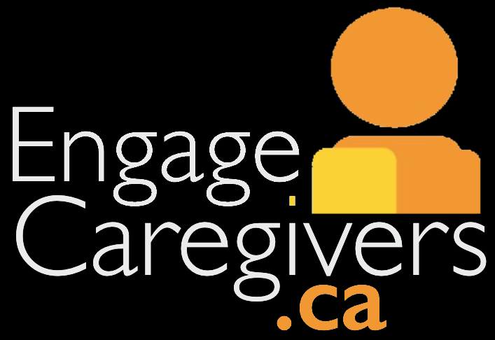
Providing Caregiver Advisor Applications
To recruit for a new Caregiver Advisor, applicants should apply to a Caregiver Advisor position using the organization’s application. We have included an application sample in Appendix A. We also recommend requesting a short resume outlining transferable skills and similar experience.
Guide: Caregiver Advisor Applications
To improve accessibility, offer multiple ways for applicants to complete the application. For example, applicants can:
- Fill out a paper copy in-person
- Complete the application over the phone
- Complete an online form available on a website or e-mail
It is not uncommon for current advisors, or staff of the organization, to recruit new Caregiver Advisors. While this may be a starting point for engagement, it is important that a Staff Liaison follows the formal application process to ensure that the position matches the caregiver’s interests, skills, experience, and readiness to get involved. If your organization does not have a Staff Liaison, ensure an employee or council/committee member is able to take on this responsibility.
The assigned Staff Liaison, staff member, or council/committee member should follow-up on applications within a week of their submission:
- If an applicant does not appear “ready” to become a Caregiver Advisor, a polite rejection response should be returned to them thanking them for their interest (Appendix B). If a rejected applicant reaches out for feedback, have a protocol in place to respond – given the right feedback, they could become a fantastic Caregiver Advisor in the future!
- If an applicant does not match a current opportunity, politely inform them that there is no available position currently for their specific skills/expertise. If the applicant is acceptable to advise on future projects, keep their information on file should an opportunity arise.
- If an applicant is ready and is matched to an opportunity, begin the interview process for the given opportunity.
While recruiting, keep in mind the broader perspective gained by recruiting for diversity. To recruit for diversity, please see the guidebook “Recruiting for Diversity” created by Health Quality Ontario (2017): https://www.hqontario.ca/Portals/0/documents/pe/recruiting-diversity-en.pdf
What does “ready” mean?
Individuals need to be emotionally ready to share and discuss their perspectives in a setting with others who may have differing views. They also must be able to approach advising from a perspective that represents the community of family caregivers, beyond their personal experience. Some experiences with the mental health care system can be traumatic and stigmatizing. If a caregiver’s interest is focused on a specific negative past experience, they may not be ready to work as a Caregiver Advisor.
Appendix A: Sample Application
Want to become a Caregiver Advisor?
As a Caregiver Advisor, you will be asked to share your perspective as a caregiver to inform on a variety of topics, such as organizational policies, quality improvement, educational materials, and/or program development. Please complete the following form so that we may know more about you and how you may fit into our current projects.
Are you…
  - A family member, friend, or caregiver of a loved one who has been a client of [sample organization] within the [sample time frame]?
  - Able to work respectfully in a collaborative environment with clients, staff, and other caregivers?
  - Willing to share your perspective in a group setting and constructively discuss concerns?
First Name: ________________________ Last Name: _______________________
Address: ___________________________ City/Town: _______________________
Telephone Number: __________________ Email: ___________________________
Can we leave a voicemail at this number? Yes No
Do you prefer to be contacted by phone or email? ______________
Which programs/services at [sample organization] have you interacted with and/or been supported by? (Select all that apply)
- Sample Service One
- Sample Service Two
- Other________________________
- Sample Service Three
- Sample Service Four

Tell us about yourself and experience with [sample organization] (300 words or less):
___________________________________________________________________________________
___________________________________________________________________________________
___________________________________________________________________________________
___________________________________________________________________________________
__________________________________________________________________________________

Tell us why you are interested in becoming a Caregiver Advisor? Any specific area of interest? (300 words or less):
___________________________________________________________________________________
___________________________________________________________________________________
___________________________________________________________________________________
___________________________________________________________________________________
___________________________________________________________________________________
___________________________________________________________________________________
___________________________________________________________________________________
Briefly explain what skills and knowledge you bring to the role (300 words or less):
___________________________________________________________________________________
___________________________________________________________________________________
___________________________________________________________________________________
___________________________________________________________________________________
___________________________________________________________________________________
___________________________________________________________________________________
___________________________________________________________________________________
Are you available to meet [fill in schedule for meeting of committee, council, project]? Yes No
Please attach a resume and any supporting documents.
___________________________________________________________________________________
Referred by: Date of Submission:
Adapted from practices at The Royal and…
A Guidebook for engaging patient and family advisors. (2016). Alberta Health Services.
How to “sell” your experience in an RSVP. (2017). Patient Voices Network.
Creating and sustaining patient and family advisory councils – guides for common challenges. (2016). Health Quality Ontario.
Appendix B: Rejection Letter
Date

Name
Address

Dear (insert name),

Thank you for your interest in becoming a Caregiver Advisor with [insert organization’s name].
We appreciate the expertise and skills you have offered in your application. However, at the current time, we are recruiting for skills and expertise that better match the specific needs of our [committee / council name].
Your perspective is valuable to us for other opportunities. We will keep your information on file and contact you should something more suitable for your skills and expertise become available. We receive a number of requests for Caregiver Advisors, and there will be additional opportunities.
For more information or questions about this opportunity, please contact [insert name] at [insert email address or phone number]. [Insert she, he, or they] can provide additional feedback about your application.

Thank you once again for your time and interest in (insert organization’s name).

Best Wishes,

